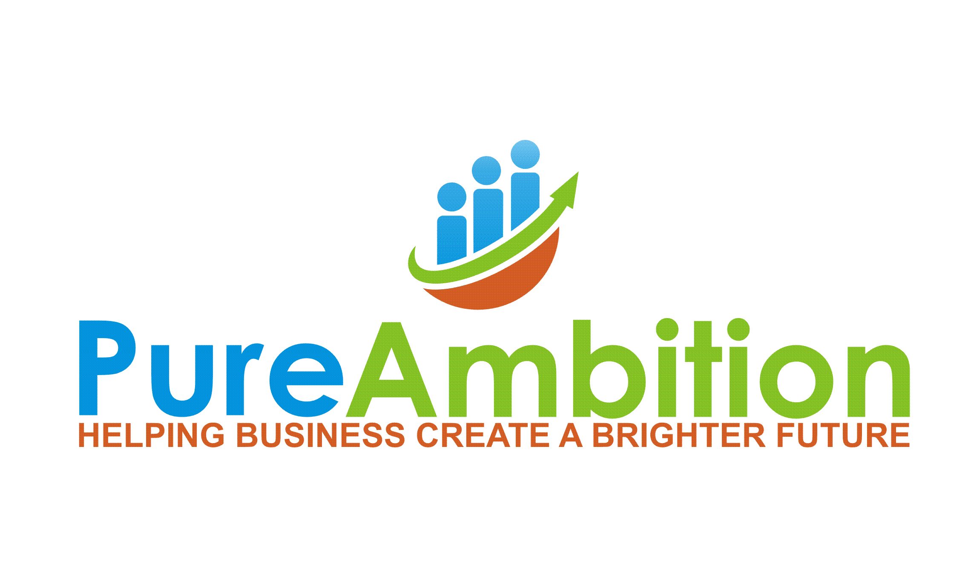

**SOCIAL IMPACT & ENVIRONMENTAL POLICY**

**1.0 PURPOSE**

This Policy is adopted in order to:

* Conserve natural resources,
* Minimize environmental impacts such as pollution and use of water and energy,
* Eliminate or reduce toxics that create hazards to workers and our community,
* Support strong recycling markets,
* Reduce materials that are landfilled,
* Increase the use and availability of environmentally preferable products that protect the environment,
* Identify environmentally preferable products and distribution systems,
* Reward manufacturers and vendors that reduce environmental impacts in their production and distribution systems or services, and
* Create a model for successfully purchasing environmentally preferable products that encourages the use of agricultural fibers, chlorine-free manufacturing processes, wood from sustainably harvested forests, and other environmentally friendly practices, and that encourages other purchasers in our community to adopt similar goals,
* Recognize the value of diversity in our supplier and partner network,
* Ensure Pure Ambition operates as a responsible corporate citizen, recognizing and embracing the impact we make across a broad base of local and global stakeholders. Our commitment to a balanced approach to environment, social and economic considerations is a core value we strive to preserve in all our endeavors.

**1.0 STATEMENT OF POLICY**

It is the policy of Pure Ambition to:

* Purchase products that minimize environmental impacts, toxics, pollution, and hazards to worker and community safety;
* Purchase products that reduce greenhouse gas emissions in their production, shipping, use and discard; and
* Purchase products that include recycled content, are durable and long-lasting, conserve energy and water, use agricultural fibers and residues, use unbleached or chlorine free manufacturing processes, are lead-free and mercury-free, and use wood from sustainably harvested forests.
* Purchase products from suppliers from underrepresented groups/sources (ie., women and minorities).
* Serve our customers and community in a way that recognizes the long-term impact of our actions.

**3.0 STRATEGIES FOR IMPLEMENTATION**

**3.1 Source Reduction**

3.1.1 Institute practices that reduce waste, encourage reuse, and result in the purchase of fewer products.

3.1.2 Purchase products that are durable, long lasting, reusable or refillable and avoid purchasing one-time use or disposable products.

3.1.3 Specify a preference for packaging that is reusable, recyclable or compostable, when suitable uses and programs exist.

3.1.4 Encourage suppliers of electronic equipment, including but not limited to computers, monitors, printers, and copiers, to take back equipment for reuse or environmentally sound recycling when Pure Ambition discards or replaces such equipment, whenever possible. Suppliers will be required to state their take back, reuse or recycling programs during the bidding process.

3.1.5 Print and copy all documents on both sides to reduce the use and purchase of paper. Printers and copiers shall be set to default to duplex.

3.1.6 Reduce the number of fax machines leased or owned by Pure Ambition.

**3.2 Recycled Content Products**

3.2.1 Purchase products for which the United States Environmental Protection Agency (U.S. EPA) has established minimum recycled content standard guidelines, such as those for printing paper, office paper, janitorial paper, construction, landscaping, parks and recreation, transportation, vehicles, miscellaneous, and non-paper office products, that contain the highest post-consumer content available, but no less than the minimum recycled content standards established by the U.S. EPA Comprehensive Procurement Guidelines.

3.2.2 Purchase copiers and printers compatible with the use of recycled content and remanufactured products.

3.2.3 Ensure pre-printed recycled content papers intended for distribution that are purchased or produced contain a statement that the paper is recycled content and indicate the percentage of post-consumer recycled content.

**3.3 Energy Efficient and Water Saving Products**

3.3.1 Purchase energy-efficient equipment with the most up-to-date energy efficiency functions. This includes, but is not limited to, high efficiency space heating systems and high efficiency space cooling equipment.

3.3.2 Replace inefficient interior lighting with energy-efficient equipment.

3.3.3 Purchase U. S. EPA Energy Star certified products when available. When Energy Star labels are not available, choose energy-efficient products that are in the upper 25% of energy efficiency as designated by the Federal Energy Management Program.

**3.5 Landscaping Products and Practices**

3.5.1 Select plants to minimize waste by choosing species for purchase that are appropriate to the microclimate, species that can grow to their natural size in the space allotted them, and perennials rather than annuals for color. Native and drought-tolerant plants that require no or minimal watering once established are preferred.

3.5.2 Hardscapes and landscape structures constructed of recycled content materials are encouraged. Limit the amount of impervious surfaces in the landscape. Permeable substitutes, such as permeable asphalt or pavers, are encouraged for walkways, patios and driveways.

**3.6 Toxics and Pollution Prevention Products and Practices**

3.6.1 Manage pest problems through prevention and physical, mechanical and biological controls when Pure Ambition and its contractors maintain buildings and landscapes. Pure Ambition may either adopt and implement an Organic Pest Management (OPM) policy and practices or adopt and implement an Integrated Pest Management (IPM) policy and practices using the least toxic pest control as a last resort.

3.6.2 Use products with the lowest amount of volatile organic compounds (VOCs), highest recycled content, low or no formaldehyde and no halogenated organic flame retardants when purchasing building maintenance materials such as paint, carpeting, adhesives, furniture and casework.

3.6.3 Purchase or require janitorial contractors to supply, industrial and institutional cleaning products that meet Green Seal or EcoLogoTM certification standards for environmental preferability and performance.

3.6.4 Purchase paper, paper products, and janitorial paper products that are unbleached or are processed without chlorine or chlorine derivatives.

3.6.5 Prohibit the purchase of products that use polyvinyl chloride (PVC) such as, but not limited to, furniture and flooring.

3.6.6 Purchase products and equipment with no lead or mercury whenever possible. For products that contain lead or mercury, Pure Ambition should give preference to those products with lower quantities of these metals and to vendors with established lead and mercury recovery programs. In addition, whenever lead- or mercury-containing products require disposal, Pure Ambition will dispose of those products in the most environmentally safe manner possible. All fluorescent lamps and batteries will be recycled.

3.6.7 Specify that desktop computers, notebooks and monitors purchased meet, at a minimum, all Electronic Product Environmental Assessment Tool (EPEAT) environmental criteria designated as “required” as contained in the IEEE 1680 Standard for the Environmental Assessment of Personal Computer Products.

3.6.8 When replacing vehicles, consider less-polluting alternatives to diesel such as compressed natural gas, bio-based fuels, hybrids, electric batteries, and fuel cells, as available.

**3.7 Bio-Based Products**

3.7.1 Encourage the use of vehicle fuels made from non-wood, plant-based contents such as vegetable oils whenever practicable.

3.7.2 Use paper, paper products and construction products made from non-wood, plant-based contents such as agricultural crops and residues.

3.7.3 Use bio-based plastic products that are biodegradable and compostable, such as bags, film, food and beverage containers, and cutlery.

3.7.4 Purchase compostable plastic products that meet American Society for Testing and Materials (ASTM) standards as found in ASTM D6400-04. Meet ASTM D6868-03 standards for biodegradable plastics used as coatings on paper and other compostable substrates.

3.7.5 Ask vendors to provide proof of compliance with ASTM standards for compostable, biodegradable and degradable plastic products upon request. One acceptable proof of compliance for compostable plastic products will be certification by the Biodegradable Products Institute (BPI).

**3.8 Forest Conservation Products**

3.8.1 To the greatest extent practicable, do not procure wood products such as lumber and paper that originate from forests harvested in an environmentally unsustainable manner. When possible, give preference to wood products that are certified to be sustainably harvested by a comprehensive, performance-based certification system. The certification system shall include independent third-party audits, with standards equivalent to, or stricter than, those of the Forest Stewardship Council certification.

3.8.2 Encourage the purchase or use of previously used or salvaged wood and wood products whenever practicable

**4.0 RESPONSIBILITIES**

4.1 The health and safety of workers and citizens is of utmost importance and takes precedence over all other practices. Nevertheless, Pure Ambition recognizes its duty to act in a fiscally responsible as well as a timely manner.

4.2 Nothing contained in this policy shall be construed as requiring a department, purchaser or contractor to procure products that do not perform adequately for their intended use, exclude adequate competition, risk the health or safety of workers and citizens, or are not available at a reasonable price in a reasonable period of time.

4.3 Nothing contained in this policy shall be construed as requiring Pure Ambition, department, purchaser, or contractor to take any action that conflicts with local, state or federal requirements.

4.4 Pure Ambition recognizes that recycled content products are essential to the continuing viability of our recycling system and for the foundation of an environmentally sound production system. Therefore, to the greatest extent practicable, recycled content shall be included in products that also meet other specifications, such as chlorine free or bio-based.

**5.0 IMPLEMENTATION**

5.1 The Founder shall implement this policy in coordination with other appropriate Pure Ambition personnel.

5.2 Require successful bidders to certify in writing that the environmental attributes claimed in competitive bids are accurate. In compliance with State law, vendors shall be required to specify the minimum or actual percentage of recovered and post-consumer material in their products, even when such percentages are zero.

5.3 Upon request, buyers making the selection from competitive bids shall be able to provide justification for product choices that do not meet the environmentally preferable purchasing criteria in this policy.

5.4 Include businesses certified by the Bay Area Green Business Program and/or Registered B Corps in purchasing requests for products and services.

5.5 Seek out and include businesses that are owned by underrepresented groups such as women and minority owned organizations in all relationships: vendors, partners, contractors, employees and charitable organizations.

5.5 Encourage vendors, contractors and grantees to comply with applicable sections of this policy for products and services provided to Pure Ambition.

**6.0 DEFINITIONS**

7.1 “American Society for Testing and Materials” means ASTM International, an open forum for the development of high quality, market relevant international standards use around the globe.

7.2 “Bay Area Green Business Program” is a partnership of governments and businesses that certifies the environmental performance of government agencies and businesses.

7.3 “Bay-Friendly Landscaping” means working with the natural ecosystems of the San Francisco Bay Area to foster soil health, to reduce runoff and pollution, prevent and reuse plant waste, and conserve water and other natural resources. Bay-Friendly Landscaping practices are described in the *Bay-Friendly Landscape Guidelines*, by StopWaste.Org.

7.4 “Bio-Based Products” means commercial or industrial products (other than food or feed) that utilize agricultural crops or residues but does not include products made from forestry materials.

7.5 “Biodegradable plastic” means the degradation of the plastic must occur as a result of the action of naturally occurring microorganisms.

7.6 “Biodegradable Products Institute” (BPI) is a multi-stakeholder association of key individuals and groups from government, industry and academia, which promotes the use, and recycling of biodegradable polymeric materials (via composting). BPI does not create standards but certifies products that demonstrate they meet the requirements in ASTM D6400 or D6868, based on testing in an approved laboratory.

7.7 “Buyer” means anyone authorized to purchase or contract for purchases on behalf of this jurisdiction or its subdivisions.

7.8 “The Carpet and Rug Institute” (CRI) is the national trade association representing the carpet and rug industry. CRI has developed and administered the “Green Label” indoor air quality testing and labeling program for carpet, adhesives, cushion materials and vacuum cleaners. The “Green Label Plus” testing program incorporates additional requirements to meet California’s Collaborative for High Performance Schools low-emitting materials criteria.

7.9 “Compostable plastic” means plastic that is biodegradable during composting to yield carbon dioxide, water and inorganic compounds and biomass, at a rate consistent with other known compostable materials and leaves no visually distinguishable or toxic residues.

7.10 “Contractor” means any person, group of persons, business, consultant, designing architect, association, partnership, corporation, supplier, vendor or other entity that has a contract with [the Organization] or serves in a subcontracting capacity with an entity having a contract with [the Organization] for the provision of goods or services.

7.11 “Degradable plastic” means plastic that undergoes significant changes in its chemical structure under specific environmental conditions.

7.12 “EcoLogoTM” is a third-party, multi-attribute eco-labeling program founded by the Canadian government in 1988. The Program compares products / services with others in the same category, develops rigorous and scientifically relevant criteria, and awards the EcoLogo to those that are environmentally preferable throughout their entire lifecycle.

7.13 “Electronic Product Environmental Assessment Tool” (EPEAT) is a procurement tool to help institutional purchasers in the public and private sectors evaluate, compare and select desktop computers, notebooks and monitors based on their environmental attributes.

7.14 “Energy Star” means the U.S. EPA’s energy efficiency product labeling program.

7.15 “Energy-Efficient Product” means a product that is in the upper 25% of energy efficiency for all similar products, or that is at least 10% more efficient than the minimum level that meets Federal standards.

7.16 “Federal Energy Management Program” is a program of the Department of Energy that issues a series of *Product Energy Efficiency Recommendations* that identify recommended efficiency levels for energy-using products.

7.17 “Forest Stewardship Council” is a global organization that certifies responsible, on-the-ground forest management according to rigorous standards developed by a broad variety of stakeholder groups.

7.18 “Green Seal” is an independent, non-profit environmental labeling organization. Green Seal standards for products and services meet the U.S. EPA’s criteria for third-party certifiers. The Green Seal is a registered certification mark that may appear only on certified products.   7.19 “Integrated Pest Management” is an ecosystem-based strategy that focuses on long-term prevention of pests or their damage through a combination of techniques such as biological control, habitat manipulation, modification of cultural practices, and use of resistant varieties. Pesticides are used only after monitoring indicates they are needed according to established guidelines, and treatments are made with the goal of removing only the target organism. Pest control materials are selected and applied in a manner that minimizes risks to human health, beneficial and non-target organisms, and the environment.

7.20 “LEED™ Rating System” means the most recent version of the Leadership in Energy and Environmental Design (LEEDTM) Commercial Green Building Rating System, or other related LEEDTM Rating System, approved by the U.S. Green Building Council and designed for rating new and existing commercial, institutional, and residential buildings.

7.21 “Organic Pest Management” prohibits the use and application of toxic chemical pesticides and strives to prevent pest problems through the application of natural, organic horticultural and maintenance practices. All pest control products shall be in keeping with, but not limited to, those products on the approved list of California Certified Organic Foods (CCOF).

7.22 "Post-consumer Material" means a finished material which would normally be disposed of as a solid waste, having reached its intended end-use and completed its life cycle as a consumer item, and does not include manufacturing or converting wastes.

7.23 “Pre-consumer Material” means material or by-products generated after manufacture of a product is completed but before the product reaches the end-use consumer. Pre-consumer material does not include mill and manufacturing trim, scrap, or broke which is generated at a manufacturing site and commonly reused on-site in the same or another manufacturing process.

7.24 “Recovered Material” means fragments of products or finished products of a manufacturing process, which has converted a resource into a commodity of real economic value, and includes pre-consumer and post-consumer material but does not include excess resources of the manufacturing process.

7.25 “Recycled Content” means the percentage of recovered material, including pre-consumer and post-consumer materials, in a product.

7.26 “Recycled Content Standard” means the minimum level of recovered material and/or post-consumer material necessary for products to qualify as “recycled products.”

7.27 “Recycled Product” means a product that meets [the Organization’s] recycled content policy objectives for post-consumer and recovered material.

7.28 “Remanufactured Product” means any product diverted from the supply of discarded materials by refurbishing and marketing said product without substantial change to its original form.

7.29 “Reused Product” means any product designed to be used many times for the same or other purposes without additional processing except for specific requirements such as cleaning, painting or minor repairs.

7.30 “Source Reduction” refers to products that result in a net reduction in the generation of waste compared to their previous or alternate version and includes durable, reusable and remanufactured products; products with no, or reduced, toxic constituents; and products marketed with no, or reduced, packaging.

7.31 “U.S. EPA Guidelines” means the Comprehensive Procurement Guidelines established by the U.S. Environmental Protection Agency for federal agency purchases as of May 2002 and any subsequent versions adopted.

7.32 “Water-Saving Products” are those that are in the upper 25% of water conservation for all similar products, or at least 10% more water-conserving than the minimum level that meets the Federal standards.

**8.0 EFFECTIVE DATES**

8.1 This policy shall take effect on 10/1/12.